

1

© Capgemini 2017. All rights reserved

|

Presentation Title | Author | Date



**Strengths**

**Achivement**

**Education and certificates**

**Base Location:**

**Email ID:**

**Mobile No:**

**Grade:**



**Agile certification**

**AWS certification**

**Trained on**

Core java,html css,javascript,spring boot,spring core,spring mvc

[/](https://sad-bardeen-ceb858.netlify.app/)

Analyst/Software Engineer

pune

Ritesh.mandal@capgemini.com

+91

8507660301

•

A self driven learner with Front

-

End and Back

-

End

knowledge. Passionate about implementing and

launching new projects.

•

Ready to learn new technologies/Frameworks and

implement them to further improve my knowledge.

•

A team player with good communication skill always

ready to work for the enrichment of knowledge.

Ready to learn new technologies to implement them to further

Improve my knowledge

Bachelor of Technology

Computer science and Engineering

2016 -2020

**Skills**

Spring Boot

Spring MVC

Spring Core

Core java

**Backend**

Spring Boot

MongoDB

**Database**

No SQL database

–

MongoDB

**Web Technologies**

HTML5

CSS3

Javascript/TypeScript

**AddOns**

Github

Maven

Postman

**Additional Details**

Excellent Communication Skills

Team Player

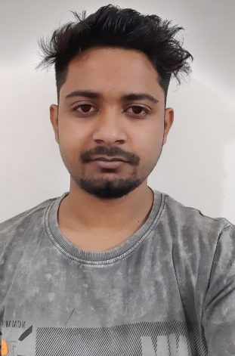

**Ritesh Mandal**



Check out my work on GitHub & Video Profile



A4